Pre-school activities Week beginning 22nd Feb 2021
Activity | Challenges
Jolly Phonics – g    https://www.youtube.com/watch?v=wiI16fMPr1Q  Workbook  My ‘g’ workbook | Watch the video about the letter ‘g’  Can you sing the Jolly Phonics songs? Can you do the action of the water going down the drain?  Can you make a collection of things in your house which begin with a ‘g’  sound ?  Print out the workbook and complete.
People Who Help Us  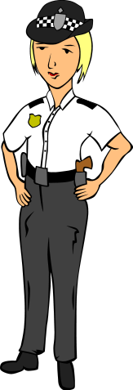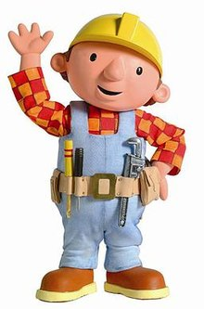  Powerpoint  People Who Help us  Worksheets  Emergency Services cut and paste  People Who Help Us and their tools matching  Small World Characters  People Who Help Us – Pencil Control | Share the powerpoint about People Who Help Us.  What do you already know about each of these jobs?  Talk about how and when these people can help us.  Complete the activities on the worksheets.  Cut out the small world characters and act out some situations where these characters are helping others.  Do you have any outfits at home to dress up in as one of these helpers?
I Spy    Worksheet  I Spy | Print out the I Spy sheet that shows lots of pictures of people who help us.  Play I Spy with a grown up, practising the sounds that the pictures begin with. If you have an alphabet chart in front of you see if you can find the letter on the chart.  Can you then count how many there are of each type of person? Can you practise writing the number on a piece of paper or white board?
Counting and colouring  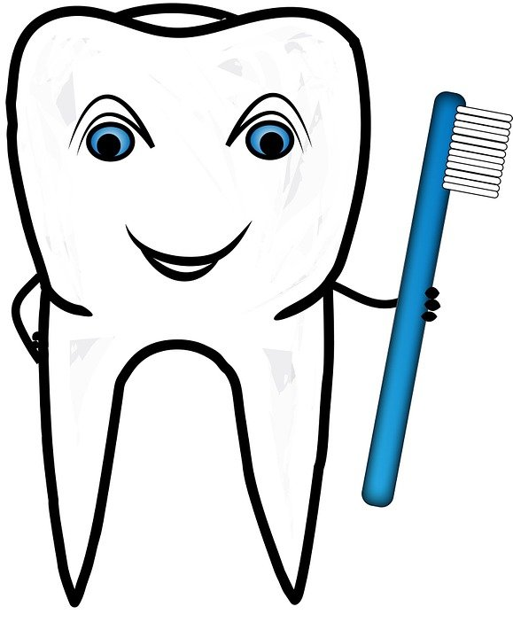  Worksheet  Count and colour sheet | Count the pictures showing people who help us on the worksheet.  Can you write the number to show the answer? Look at a number chart if you are not sure how to record the numeral.
People Who Help Us Song    You Tube  https://www.youtube.com/watch?v=M8Psza6N2Os | Can you join in with the song on You Tube?  (You will need a grown up to read the words to you)  Can you make up your own verses about other people who help us?
Feelings  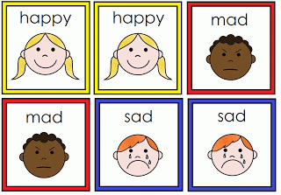  You Tube  https://www.youtube.com/watch?v=-J7HcVLsCrY | Watch the video about Feelings on You Tube.  Talk about how you are feeling today.  What things make you feel happy? What makes you feel sad? What can help you to feel better when you are sad?  Now go and do something that makes you feel happy ☺
People Who Help Us – Doctors and Dentist      Power Points  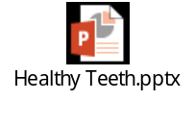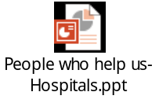 | Watch the power points all about Doctors and Dentists and how they help us.  Talk to your parents about how we need Doctors and Dentists to look after us.  Next can you draw a pictures of some healthy food and drinks you should have to help look after your teeth?  Then you can draw a picture of some special tools a doctor uses to examine us.
Representing Numbers  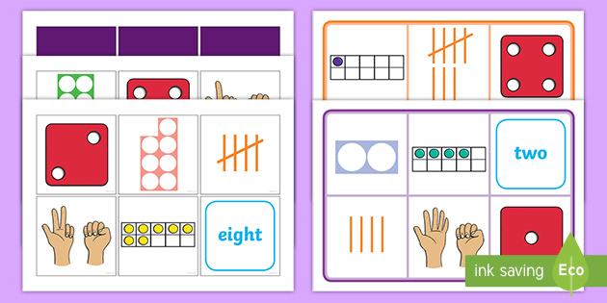  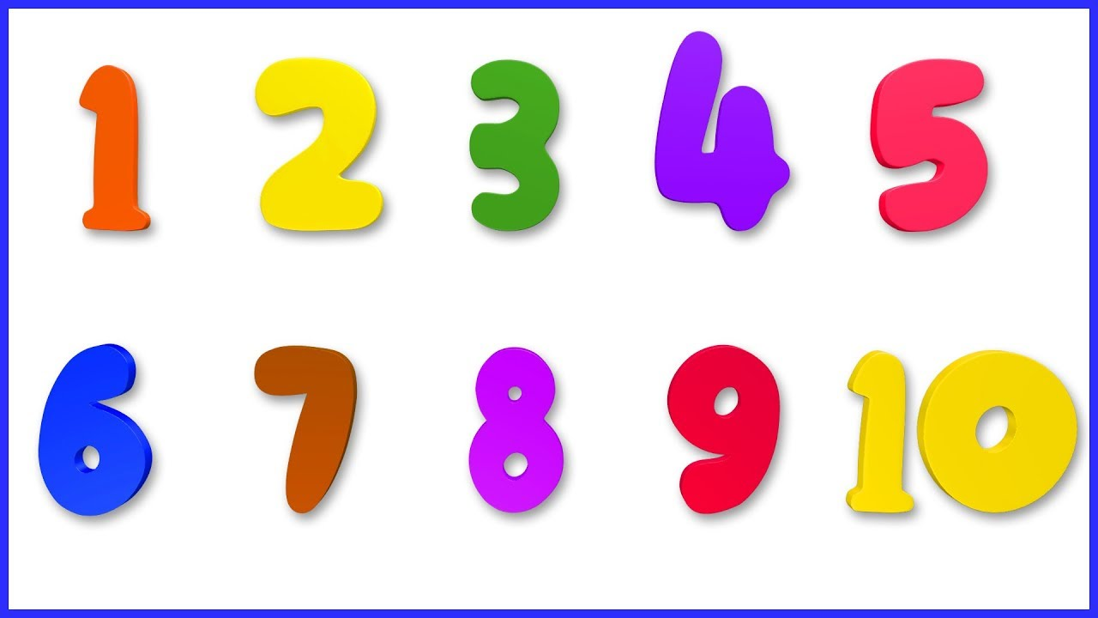 | Choose a number from 1-10 and have a go at representing it in different ways.  You might show 2 fingers, get 5 objects, draw 3 circles etc.  Try to remember to take a picture of what you have come up with.

