Pre-school activities Week beginning 18th Jan 2021
Activity | Challenges
Jolly Phonics – e  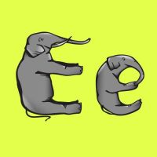  https://www.youtube.com/watch?v=4TmOJh3W90w  Workbook  My ‘e’ workbook | Watch the video about the letter ‘e’  Can you sing the Jolly Phonics songs? Can you pretend to crack an egg when you sing?  Can you make a collection of things in your house which begin with an ‘e’ sound ?  Print out the workbook and complete.
Matching and ordering numbers.  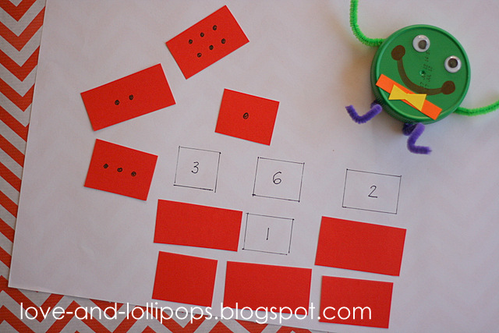  Worksheet  Humpty Dumpty matching numbers | Can you make a matching number wall for Humpty like in the picture?  You could also print out the worksheet and have a go at matching together the numbered Humpty pieces and putting them in order.
Humpty Dumpty  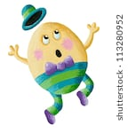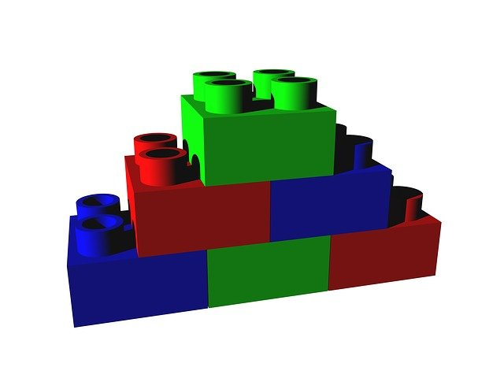  Humpty Dumpty | Kids Songs | Super Simple Songs - Bing video  Worksheets  Humpty Dumpty Stick Puppets  Humpty Dumpty cutting activity  Humpty Dumpty Pencil control  Humpty Dumpty colouring | Watch the Rhyme about Humpty Dumpty.  Can you use some bricks to build a strong wall. Look at the pattern in the picture. Can you make your wall strong by putting one brick on top of two others so that you are covering the gap and joining them together.?  Print out the pictures to make the stick puppets. You can act out the rhyme.  Practice your cutting by sticking all the pieces of Humpty together. You can also practice your pencil control.  When you have coloured in the pictures can you order them to tell the rhyme?
Noah’s Ark  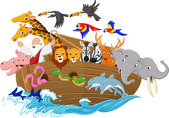  Noah’s Ark Powerpoint  Craft activity - Paper plate animals | Watch the story of Noah’s Ark on the Powerpoint and discuss.  Have a go at making some paper plate animals. Can you make two of each?
Two by Two Song  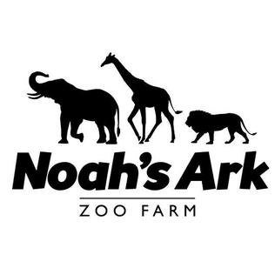  https://www.bing.com/videos/search?q=you+tube+the+animals+went+in+two+by+two+song&&view=detail&mid=C14EEC0D47EC60317F71C14EEC0D47EC60317F71&&FORM=VDRVRV | Watch and join in with the Two by Two song.  Do you know which number will come next?  Discuss the words which rhyme e.g. four and door
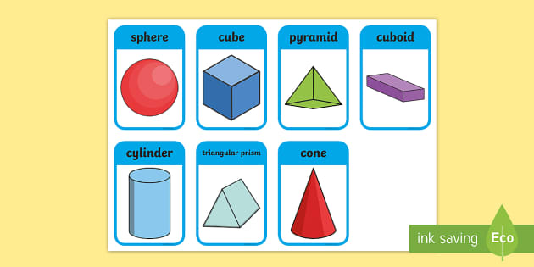  3D Shapes song and activity  https://www.youtube.com/watch?v=guNdJ5MtX1A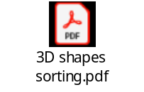 | Listen and join in with the song.  Can you recognise and name the shapes?  Next print off and complete the 3D shape sorting activity.
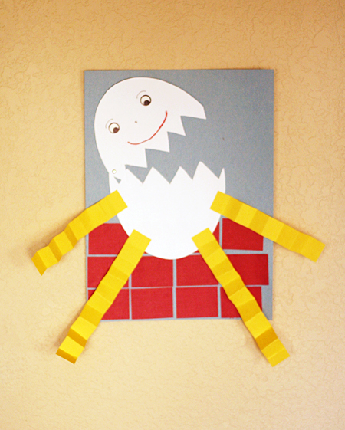  Humpty Dumpty collage | Can you create a Humpty Dumpty collage like the picture to the left?  Make sure to build a wall for him to sit on too ☺
Floating or sinking  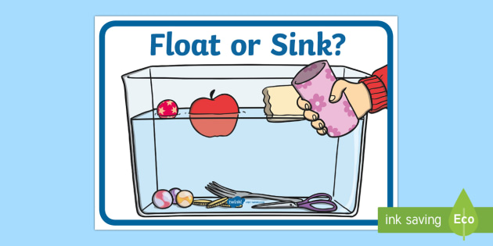  https://www.youtube.com/watch?v=s2DTW0EMigk  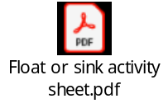 | Watch the CBeebies video about floating and sinking.  Print off the sheet and try your own ‘Float or Sink’ experiment. You can do this is a bucket of water or even in your bath.  Talk about the materials of the different objects and if you know why they floated or sank.

